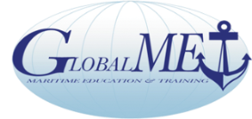

Global Maritime Education and Training Association

GlobalMET Limited ACN 103 233 754

Chair: Capt Pradeep Chawla- Anglo Eastern Group

ExecSec: Capt Richard Teo PO Box 106, Burnie Tas 7320, Australia

Secretariat: Core Competency Training & Services 1070 10F Tower B1 Spaze iTech Park Gurgaon 122002 India

Tel 91 124 45525 59 secretariat@globalmet.org www.globalmet.org
The MET Network with NGO Observer Status at IMO

CONSENT TO ACT AS DIRECTOR
(Corporations Act; Sect 201D)

I, _______________________________being an Individual representing the,

Name of Member Organisation : ALAM

do hereby consent to act as a Director on the Board of GlobalMET Limited

This consent is automatically extended at the next AGM and or annually, unless otherwise stated.

Signed _______________________________

Date _______________________________

Please note:

Personal Details and Disclosures under Section 192 Corporations Act
DOB ………………………………………….
Place of Birth …………………………………
Other Directorships: ………………………….
………………………….
………………………….
Australian Resident: Yes /No
Nationality .........................................
Current Address: ………………………….
………………………….
Personal Interests – no conflict of interests (* add list if any…………………)

